**Collaborative Filtering**[**¶**](https://jupyterlab-6-labs-prod-jupyterlab-us-east-2.labs.cognitiveclass.ai/user/akulasamson/lab/tree/labs/coursera/ML0101EN/ML0101EN-RecSys-Collaborative-Filtering-movies.ipynb#Collaborative-Filtering)

Estimated time needed: **25** minutes

**Objectives**

After completing this lab you will be able to:

* Create recommendation system based on collaborative filtering

Recommendation systems are a collection of algorithms used to recommend items to users based on information taken from the user. These systems have become ubiquitous can be commonly seen in online stores, movies databases and job finders. In this notebook, we will explore recommendation systems based on Collaborative Filtering and implement simple version of one using Python and the Pandas library.

**Table of contents**

1. [Acquiring the Data](https://jupyterlab-6-labs-prod-jupyterlab-us-east-2.labs.cognitiveclass.ai/user/akulasamson/files/labs/coursera/ML0101EN/https%3A/%23ref1?_xsrf=2%7Ca7f4a81a%7Ce6603221b834df77feef1f336d6809ff%7C1631553139)
2. [Preprocessing](https://jupyterlab-6-labs-prod-jupyterlab-us-east-2.labs.cognitiveclass.ai/user/akulasamson/files/labs/coursera/ML0101EN/https%3A/%23ref2?_xsrf=2%7Ca7f4a81a%7Ce6603221b834df77feef1f336d6809ff%7C1631553139)
3. [Collaborative Filtering](https://jupyterlab-6-labs-prod-jupyterlab-us-east-2.labs.cognitiveclass.ai/user/akulasamson/files/labs/coursera/ML0101EN/https%3A/%23ref3?_xsrf=2%7Ca7f4a81a%7Ce6603221b834df77feef1f336d6809ff%7C1631553139)

**Acquiring the Data**

To acquire and extract the data, simply run the following Bash scripts:  
Dataset acquired from [GroupLens](http://grouplens.org/datasets/movielens/?utm_medium=Exinfluencer&utm_source=Exinfluencer&utm_content=000026UJ&utm_term=10006555&utm_id=NA-SkillsNetwork-Channel-SkillsNetworkCoursesIBMDeveloperSkillsNetworkML0101ENSkillsNetwork20718538-2021-01-01). Let's download the dataset. To download the data, we will use **!wget** to download it from IBM Object Storage.  
**Did you know?** When it comes to Machine Learning, you will likely be working with large datasets. As a business, where can you host your data? IBM is offering a unique opportunity for businesses, with 10 Tb of IBM Cloud Object Storage: [Sign up now for free](http://cocl.us/ML0101EN-IBM-Offer-CC)

[ ]:



**!**wget **-**O moviedataset.zip https:**//**cf**-**courses**-**data.s3.us.cloud**-**object**-**storage.appdomain.cloud**/**IBMDeveloperSkillsNetwork**-**ML0101EN**-**SkillsNetwork**/**labs**/**Module**%**205**/**data**/**moviedataset.zip

print('unziping ...')

**!**unzip **-**o **-**j moviedataset.zip

Now you're ready to start working with the data!

**Preprocessing**

First, let's get all of the imports out of the way:

[ ]:



*#Dataframe manipulation library*

**import** pandas **as** pd

*#Math functions, we'll only need the sqrt function so let's import only that*

**from** math **import** sqrt

**import** numpy **as** np

**import** matplotlib.pyplot **as** plt

**%**matplotlib inline

Now let's read each file into their Dataframes:

[ ]:



*#Storing the movie information into a pandas dataframe*

movies_df **=** pd.read_csv('movies.csv')

*#Storing the user information into a pandas dataframe*

ratings_df **=** pd.read_csv('ratings.csv')

Let's also take a peek at how each of them are organized:

[ ]:



*#Head is a function that gets the first N rows of a dataframe. N's default is 5.*

movies_df.head()

So each movie has a unique ID, a title with its release year along with it (Which may contain unicode characters) and several different genres in the same field. Let's remove the year from the title column and place it into its own one by using the handy [extract](http://pandas.pydata.org/pandas-docs/stable/generated/pandas.Series.str.extract.html?utm_medium=Exinfluencer&utm_source=Exinfluencer&utm_content=000026UJ&utm_term=10006555&utm_id=NA-SkillsNetwork-Channel-SkillsNetworkCoursesIBMDeveloperSkillsNetworkML0101ENSkillsNetwork20718538-2021-01-01#pandas.Series.str.extract) function that Pandas has.

Let's remove the year from the **title** column by using pandas' replace function and store in a new **year** column.

[ ]:



*#Using regular expressions to find a year stored between parentheses*

*#We specify the parantheses so we don't conflict with movies that have years in their titles*

movies_df['year'] **=** movies_df.title.str.extract('(\(\d\d\d\d\))',expand**=False**)

*#Removing the parentheses*

movies_df['year'] **=** movies_df.year.str.extract('(\d\d\d\d)',expand**=False**)

*#Removing the years from the 'title' column*

movies_df['title'] **=** movies_df.title.str.replace('(\(\d\d\d\d\))', '')

*#Applying the strip function to get rid of any ending whitespace characters that may have appeared*

movies_df['title'] **=** movies_df['title'].apply(**lambda** x: x.strip())

Let's look at the result!

[ ]:



movies_df.head()

With that, let's also drop the genres column since we won't need it for this particular recommendation system.

[ ]:



*#Dropping the genres column*

movies_df **=** movies_df.drop('genres', 1)

Here's the final movies dataframe:

[ ]:



movies_df.head()

Next, let's look at the ratings dataframe.

[ ]:



ratings_df.head()

Every row in the ratings dataframe has a user id associated with at least one movie, a rating and a timestamp showing when they reviewed it. We won't be needing the timestamp column, so let's drop it to save on memory.

[ ]:



*#Drop removes a specified row or column from a dataframe*

ratings_df **=** ratings_df.drop('timestamp', 1)

Here's how the final ratings Dataframe looks like:

[ ]:



ratings_df.head()

**Collaborative Filtering**

Now it's time to start our work on recommendation systems.

The first technique we're going to take a look at is called **Collaborative Filtering**, which is also known as **User-User Filtering**. As hinted by its alternate name, this technique uses other users to recommend items to the input user. It attempts to find users that have similar preferences and opinions as the input and then recommends items that they have liked to the input. There are several methods of finding similar users (Even some making use of Machine Learning), and the one we will be using here is going to be based on the **Pearson Correlation Function**.

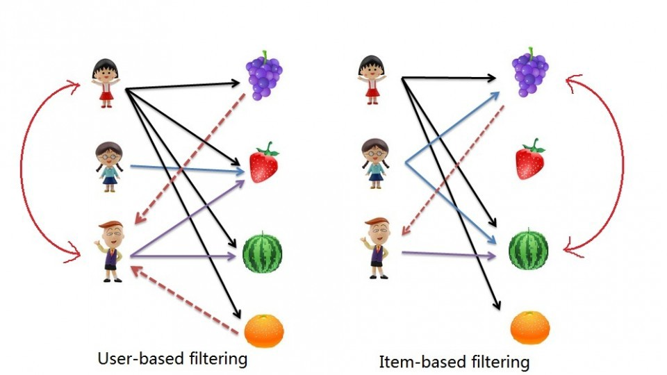

The process for creating a User Based recommendation system is as follows:

* Select a user with the movies the user has watched
* Based on his rating to movies, find the top X neighbours
* Get the watched movie record of the user for each neighbour.
* Calculate a similarity score using some formula
* Recommend the items with the highest score

Let's begin by creating an input user to recommend movies to:

Notice: To add more movies, simply increase the amount of elements in the userInput. Feel free to add more in! Just be sure to write it in with capital letters and if a movie starts with a "The", like "The Matrix" then write it in like this: 'Matrix, The' .

[ ]:



userInput **=** [

{'title':'Breakfast Club, The', 'rating':5},

{'title':'Toy Story', 'rating':3.5},

{'title':'Jumanji', 'rating':2},

{'title':"Pulp Fiction", 'rating':5},

{'title':'Akira', 'rating':4.5}

]

inputMovies **=** pd.DataFrame(userInput)

inputMovies

**Add movieId to input user**

With the input complete, let's extract the input movies's ID's from the movies dataframe and add them into it.

We can achieve this by first filtering out the rows that contain the input movies' title and then merging this subset with the input dataframe. We also drop unnecessary columns for the input to save memory space.

**Did you know? IBM Watson Studio lets you build and deploy an AI solution, using the best of open source and IBM software and giving your team a single environment to work in.**[**Learn more here.**](https://cocl.us/ibm_watson_studio_infobox)

[ ]:



*#Filtering out the movies by title*

inputId **=** movies_df[movies_df['title'].isin(inputMovies['title'].tolist())]

*#Then merging it so we can get the movieId. It's implicitly merging it by title.*

inputMovies **=** pd.merge(inputId, inputMovies)

*#Dropping information we won't use from the input dataframe*

inputMovies **=** inputMovies.drop('year', 1)

*#Final input dataframe*

*#If a movie you added in above isn't here, then it might not be in the original*

*#dataframe or it might spelled differently, please check capitalisation.*

inputMovies

**The users who has seen the same movies**

Now with the movie ID's in our input, we can now get the subset of users that have watched and reviewed the movies in our input.

[ ]:



*#Filtering out users that have watched movies that the input has watched and storing it*

userSubset **=** ratings_df[ratings_df['movieId'].isin(inputMovies['movieId'].tolist())]

userSubset.head()

We now group up the rows by user ID.

[ ]:



*#Groupby creates several sub dataframes where they all have the same value in the column specified as the parameter*

userSubsetGroup **=** userSubset.groupby(['userId'])

Let's look at one of the users, e.g. the one with userID=1130.

[ ]:



userSubsetGroup.get_group(1130)

Let's also sort these groups so the users that share the most movies in common with the input have higher priority. This provides a richer recommendation since we won't go through every single user.

[ ]:



*#Sorting it so users with movie most in common with the input will have priority*

userSubsetGroup **=** sorted(userSubsetGroup, key**=lambda** x: len(x[1]), reverse**=True**)

Now let's look at the first user.

[ ]:



userSubsetGroup[0:3]

**Similarity of users to input user**

Next, we are going to compare all users (not really all !!!) to our specified user and find the one that is most similar.  
we're going to find out how similar each user is to the input through the **Pearson Correlation Coefficient**. It is used to measure the strength of a linear association between two variables. The formula for finding this coefficient between sets X and Y with N values can be seen in the image below.

Why Pearson Correlation?

Pearson correlation is invariant to scaling, i.e. multiplying all elements by a nonzero constant or adding any constant to all elements. For example, if you have two vectors X and Y,then, pearson(X, Y) == pearson(X, 2 * Y + 3). This is a pretty important property in recommendation systems because for example two users might rate two series of items totally different in terms of absolute rates, but they would be similar users (i.e. with similar ideas) with similar rates in various scales .

The values given by the formula vary from r = -1 to r = 1, where 1 forms a direct correlation between the two entities (it means a perfect positive correlation) and -1 forms a perfect negative correlation.

In our case, a 1 means that the two users have similar tastes while a -1 means the opposite.

We will select a subset of users to iterate through. This limit is imposed because we don't want to waste too much time going through every single user.

[ ]:



userSubsetGroup **=** userSubsetGroup[0:100]

Now, we calculate the Pearson Correlation between input user and subset group, and store it in a dictionary, where the key is the user Id and the value is the coefficient.

[ ]:



*#Store the Pearson Correlation in a dictionary, where the key is the user Id and the value is the coefficient*

pearsonCorrelationDict **=** {}

​

*#For every user group in our subset*

**for** name, group **in** userSubsetGroup:

*#Let's start by sorting the input and current user group so the values aren't mixed up later on*

group **=** group.sort_values(by**=**'movieId')

inputMovies **=** inputMovies.sort_values(by**=**'movieId')

*#Get the N for the formula*

nRatings **=** len(group)

*#Get the review scores for the movies that they both have in common*

temp_df **=** inputMovies[inputMovies['movieId'].isin(group['movieId'].tolist())]

*#And then store them in a temporary buffer variable in a list format to facilitate future calculations*

tempRatingList **=** temp_df['rating'].tolist()

*#Let's also put the current user group reviews in a list format*

tempGroupList **=** group['rating'].tolist()

*#Now let's calculate the pearson correlation between two users, so called, x and y*

Sxx **=** sum([i**\*\***2 **for** i **in** tempRatingList]) **-** pow(sum(tempRatingList),2)**/**float(nRatings)

Syy **=** sum([i**\*\***2 **for** i **in** tempGroupList]) **-** pow(sum(tempGroupList),2)**/**float(nRatings)

Sxy **=** sum( i**\***j **for** i, j **in** zip(tempRatingList, tempGroupList)) **-** sum(tempRatingList)**\***sum(tempGroupList)**/**float(nRatings)

*#If the denominator is different than zero, then divide, else, 0 correlation.*

**if** Sxx **!=** 0 **and** Syy **!=** 0:

pearsonCorrelationDict[name] **=** Sxy**/**sqrt(Sxx**\***Syy)

**else**:

pearsonCorrelationDict[name] **=** 0

​

[ ]:



pearsonCorrelationDict.items()

[ ]:



pearsonDF **=** pd.DataFrame.from_dict(pearsonCorrelationDict, orient**=**'index')

pearsonDF.columns **=** ['similarityIndex']

pearsonDF['userId'] **=** pearsonDF.index

pearsonDF.index **=** range(len(pearsonDF))

pearsonDF.head()

**The top x similar users to input user**

Now let's get the top 50 users that are most similar to the input.

[ ]:



topUsers**=**pearsonDF.sort_values(by**=**'similarityIndex', ascending**=False**)[0:50]

topUsers.head()

Now, let's start recommending movies to the input user.

**Rating of selected users to all movies**

We're going to do this by taking the weighted average of the ratings of the movies using the Pearson Correlation as the weight. But to do this, we first need to get the movies watched by the users in our **pearsonDF** from the ratings dataframe and then store their correlation in a new column called _similarityIndex". This is achieved below by merging of these two tables.

[ ]:



topUsersRating**=**topUsers.merge(ratings_df, left_on**=**'userId', right_on**=**'userId', how**=**'inner')

topUsersRating.head()

Now all we need to do is simply multiply the movie rating by its weight (The similarity index), then sum up the new ratings and divide it by the sum of the weights.

We can easily do this by simply multiplying two columns, then grouping up the dataframe by movieId and then dividing two columns:

It shows the idea of all similar users to candidate movies for the input user:

[ ]:



*#Multiplies the similarity by the user's ratings*

topUsersRating['weightedRating'] **=** topUsersRating['similarityIndex']**\***topUsersRating['rating']

topUsersRating.head()

[ ]:



*#Applies a sum to the topUsers after grouping it up by userId*

tempTopUsersRating **=** topUsersRating.groupby('movieId').sum()[['similarityIndex','weightedRating']]

tempTopUsersRating.columns **=** ['sum_similarityIndex','sum_weightedRating']

tempTopUsersRating.head()

[ ]:



*#Creates an empty dataframe*

recommendation_df **=** pd.DataFrame()

*#Now we take the weighted average*

recommendation_df['weighted average recommendation score'] **=** tempTopUsersRating['sum_weightedRating']**/**tempTopUsersRating['sum_similarityIndex']

recommendation_df['movieId'] **=** tempTopUsersRating.index

recommendation_df.head()

Now let's sort it and see the top 20 movies that the algorithm recommended!

[ ]:



recommendation_df **=** recommendation_df.sort_values(by**=**'weighted average recommendation score', ascending**=False**)

recommendation_df.head(10)

[ ]:



movies_df.loc[movies_df['movieId'].isin(recommendation_df.head(10)['movieId'].tolist())]

**Advantages and Disadvantages of Collaborative Filtering**

**Advantages**

* Takes other user's ratings into consideration
* Doesn't need to study or extract information from the recommended item
* Adapts to the user's interests which might change over time

**Disadvantages**

* Approximation function can be slow
* There might be a low of amount of users to approximate
* Privacy issues when trying to learn the user's preferences